Click on the link in the email.
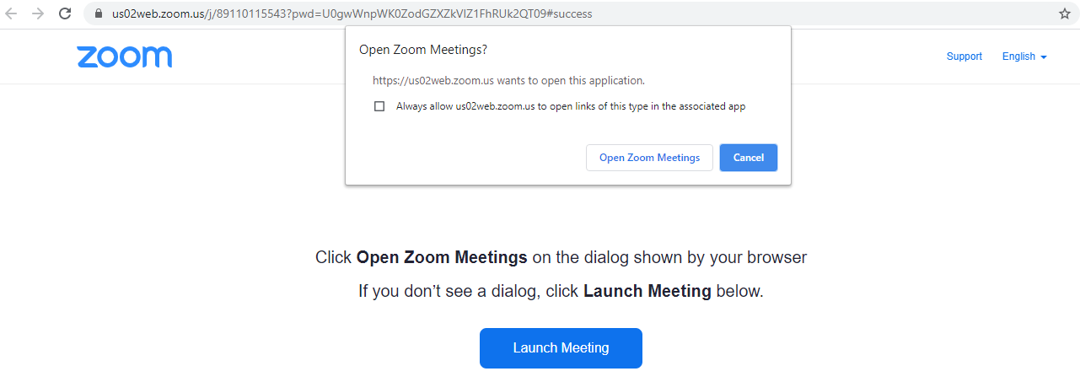
Click Open Zoom Meeting
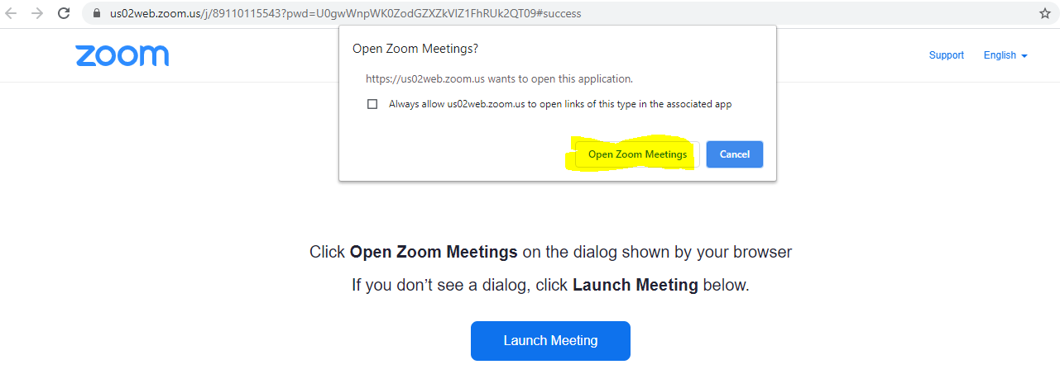
Click “Join with Computer Audio”
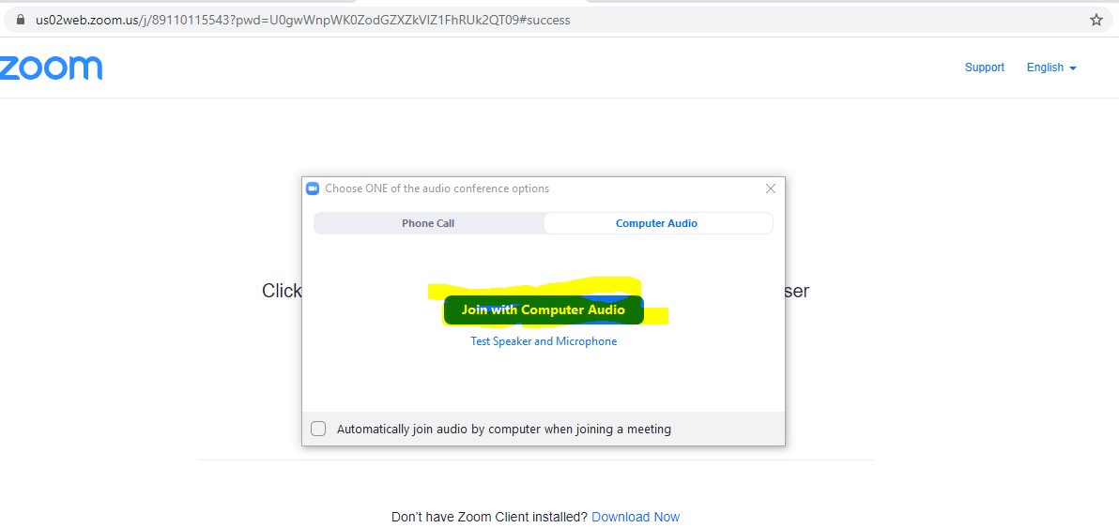
After a pause you will enter the online meeting.
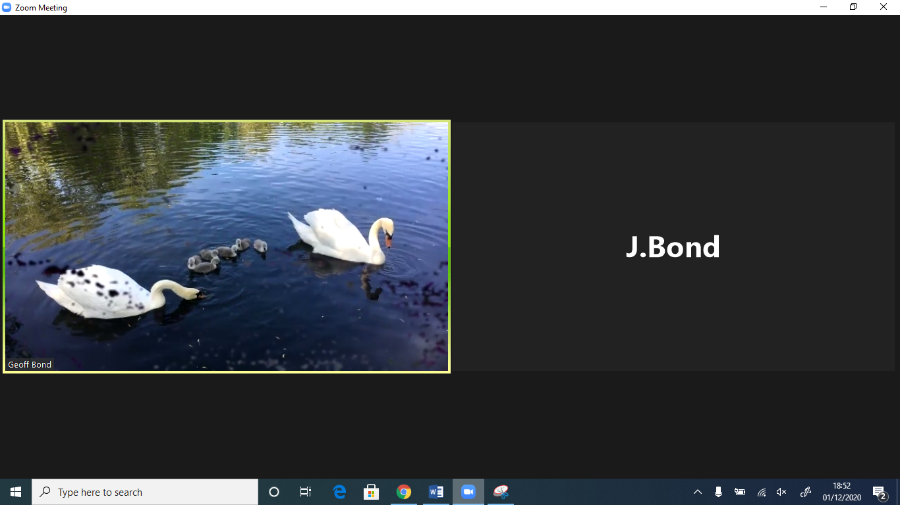
If you would like to comment or ask questions in the meeting hover over the bottom bar and click “chat”.
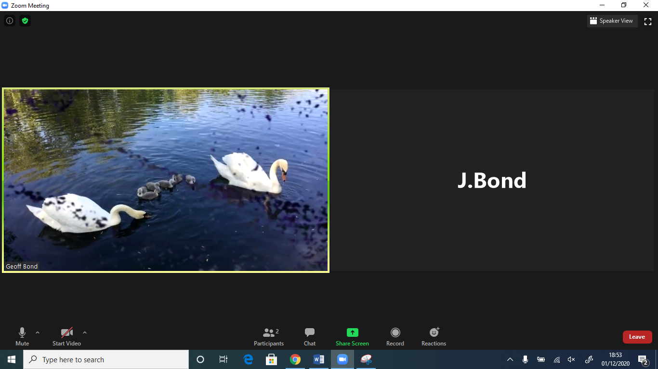
You can then type into the box where it says “type here”. This will appear to everyone in the meeting when you press enter or return. You can also email admin@hamandpetersham.com with questions though this may not be immediate.
